**A Guide to the Use of Marks in Senior Science Assessment in Queensland**

DISCLAIMER

In many regards using marks in the conventional sense is incompatible with the present science syllabuses because, right from their conception, it was planned that marks could not be used. The intention was made clear at meetings prior to the introduction of the syllabus and in the written advice provided by the QSA to senior science teachers:

“An analysis of the underlying assumptions shows that numerical marking systems enjoy a status that is higher than they strictly deserve. **The use of marks in criteria-based assessment is inappropriate** for two sets of reasons. Firstly, the assumptions are not generally satisfied in any form of school-based assessment, and secondly, the use of marks as currency in grade-exchange transactions diverts attention away from criteria, standards, and the processes of qualitative appraisals, and to that extent is educationally counterproductive.”

*The importance of instrument-specific criteria and standards: Moving on from marks*.

(QSA, July 2008)

This was despite the fact the other states use marks and successfully align them to standards. Thus we are applying a “band-aid” solution for the student cohort starting in 2014 while awaiting more fundamental changes in subsequent years. For this reason unfortunate compromises have been inevitable in designing his guide. This would not have been the case if the original syllabuses were not fundamentally flawed in the first place and adopted the approaches elsewhere. This should be borne in mind while applying the ideas of the guide.

**Background**

The Education and Innovation Committee of the Queensland Parliament on October 14 2013 published the ‘Menkens Report’ comprising a summary, findings and recommendations produced as a result of the Parliamentary Inquiry into the assessment methods used in senior mathematics, chemistry and physics in Queensland schools (<http://www.parliament.qld.gov.au/documents/committees/EIC/2013/QldAssessment/rpt-025-14Oct2013.pdf>).

As a consequence the Minister for Education has asked the Queensland Studies Authority to “write to all principals clarifying the use of numerical marking, and develop resources that explain how marks can be linked to syllabus standards and criteria.”

This guide has been prepared by experienced senior science teachers to disseminate strategies and protocols for using marks in assessment instruments while still meeting the requirements of the current senior syllabuses for Chemistry, Physics and Biology. Specific examples for Chemistry have been supplied. A ‘minimalist’ approach has been adopted which would allow many schools to retain their current work programs and assessment packages with only modest adjustments. It also provides a model of how the results from the instruments in a school work program can be combined in a student profile to determine an overall level of achievement and rung placement.

Aligning Marks and Percentages to the Criteria Standards

Amongst the key recommendations of the Menkens Inquiry were that numerical marking be reintroduced in maths and science with mark ranges equating to each of the five standards of achievement for each of the three global objectives criteria. The inquiry highlighted as an exemplar the Victorian model of marks aligned to criteria. In that state a 50 point scale is often used in senior science assessment with 10 points allocated to each of the five A-E bands. It provides a convenient model for the use of marks in Queensland assessment as the 50 point scale can be aligned to the 50 rungs available for student placement at verification (Figure 1).

Figure 1. Alignment of Standards and Exit Criteria to Percentages

| Criterion | A | B | C | D | E |
| --- | --- | --- | --- | --- | --- |
|  | > 80% | > 60% | > 40% | > 20% | < 20% |
| *Knowledge and conceptual understanding* |  |  |  |  |  |
|  |  |  |  |  |
|  |  |  |  |  |
| *Investigative processes* |  |  |  |  |  |
|  |  |  |  |  |
|  |  |  |  |  |
| *Evaluating and concluding* |  |  |  |  |  |
|  |  |  |  |  |
|  |  |  |  |  |

**Awarding exit levels of achievement**

|  |  |
| --- | --- |
| * VHA | * Standard *A(>80%)*  in any two criteria and no less than a *B* in the remaining criterion |
| * HA | * Standard *B* (>60%) in any two criteria and no less than a *C* in the remaining criterion |
| * SA | * Standard *C* (>40%) in any two criteria and no less than a *D* in the remaining criterion |
| * LA | * At least Standard *D* (>20%) in any two criteria |
| * VLA | * Standard *E* in two of the three criteria |

Under the previous Queensland senior science syllabuses school work programs allowed different instruments to make weighted contributions to final grades. This was achieved by allocating a higher proportion of marks to certain instruments and less to others. The current syllabuses stipulate that *'The exit criteria are to have equal emphasis across the range of summative assessment*’ and *'All criteria make equal contribution to the determination of levels of exit achievement.*' Different instruments cannot be weighted and all instruments and the criteria applied under the three global objects must be treated equally.

It is possible to design a student profile that can determine LOAs by aggregating the marks and calculating final percentages as in the previous syllabuses. This can be achieved by allocating the same number of total marks to each of the criteria in each instrument, e.g. 50 marks for KCU, IP and EC as the case may be. In practice schools may find it much simpler and more convenient to convert the results for each of the criteria in each instrument to a percentage. The percentages can then be aggregated and averaged on the student profile (Figure 2) which is a simpler approach to fulfilling the syllabus requirement of equal weighting for the instruments and global objectives.

When assigning students to rungs at verification and exit percentages can be averaged across the three general objectives to give an overall percentage provided the conditions in the tables are met. As percentages effectively represent a 100 point scale achievement band rung boundaries exist at increments of 2% (**rung = %/2**), e.g., a student with an overall average achievement percentage of 61% is placed at HA1 and a student with 73% placed at HA6.

At verification panellists must still determine if school assessment packages allow students to display the full range of syllabus standards. As in the previous syllabuses where marks and percentage cut-offs were used panel will either support or change student placement by schools based on their professional judgement of the alignment of instruments to the standards and the quality of the student work.

Figure 2. Student Profile Exemplar

**Upper Cumbucta West College**

**Senior Chemistry Student Profile**

**Year:** *2014* **Student:** *Jane McGillicuddy*

|  |  |  |  |  |  |  |
| --- | --- | --- | --- | --- | --- | --- |
| **Year** | **Assessment Instrument** | | **Technique category** | **KCU** | **IP** | **EC** |
| Year 12 | 6. Replacement Fuels | | ERT | *18*/25  %= **72** | *16*/25  %= **64** | *13*/25  %= **52** |
| 7. End Semester 3 Exam: Energy & Organics | | SA | *39*/50  %= **78** | *35*/50  %= **70** | *27*/50  %= **54** |
| 8. Wine in a Cup | | EEI | *34*/50  %= **60** | *46*/75  %= **61** | *39*/75  %= **52** |
| 9. Mid-semester 4 Exam: Gases & Equilibrium | | SA | *40*/50  %= **80** | *33*/50  %= **66** | *30*/50  %= **60** |
| **Verification** | Av % =  L.O.A = | | **72.5 %** | **65.3 %** | **54.5 %** |
| ***B*** | *B-* | *C+* |
| ***64.1 %*** *= B- =* ***HA2*** | | |
| 10. Acid-Base Equilibria | | SA | *35*/50  %= **70** | *30*/50  %= **60** | *27*/50  %= **54** |
| **Exit** | Av % =  L.O.A = | | **72.0 %** | **64.2 %** | **54.4 %** |
| ***B*** | *B-* | *C+* |
| ***63.5 %*** *= B- = HA1* | | |

Applying the Use of Marks in Assessment Instruments

1. Multiple Component Questions in Supervised Assessment Instruments

Many schools use exam formats for Supervised Assessments (SA). Multiple component questions are a ‘classical’ style of question comprising either clearly identified components ((a), (b), (c), etc.) of increasing challenge or extensive multistep calculations of increasing complexity.

If this approach is used in the design of an instrument then:

* Each question should assess just one of the global objectives;
* The mark for the same standard in each question should be the same;
* Each component should by en large not ‘cue’ the student towards the correct response of the next component.

By following these guidelines a consistent approach is provided to mark allocation which allows the marks from different questions to be aggregated, converted to a final percentage and reflect the syllabus standards. There is sometimes a difficulty in determining which global objective an individual question applies to. In practice investigative and evaluating questions always require some content knowledge and this area remains a contentious issue in the Queensland syllabuses. The only practical solution is to identify which of the global objectives an item best applies to and allocate it accordingly.

A simple example for multiple component questions is to allocate 4 marks (40%) to the components covering the E-D bands, 2 marks to the components covering the C band (20%) and 4 marks to the components covering the A and B bands (40%) for a total of 10 marks. A greater number of marks can be applied to lengthy questions with the proviso that no more than 40% be allocated to the ‘A/B’ standard components.

With this approach the marks for each component can be aggregated with the results showing alignment to the percentage cut-offs. This also resolves the issue where a student performs well on the ‘A’ components but poorly on the easier ‘C’ and ‘D’ components. In this situation the student might not obtain an ‘A’ but a ‘B’. While some might argue that the student shows ‘A’ grade responses and should be awarded an ‘A’ the Menkens Inquiry highlighted the need for students to be competent at basic knowledge and skills. As a result a clear direction has been given that ‘A’ grade students must be competent at BOTH ‘higher order’ skills AND recall of knowledge/application of basic skills. A student that consistently achieves well in higher order questions but poorly in basic knowledge can no longer be considered to be of ‘A’ standard in this state.

Figure 3. Exemplar of the Use of Marks in a Multiple Component Question (IP)

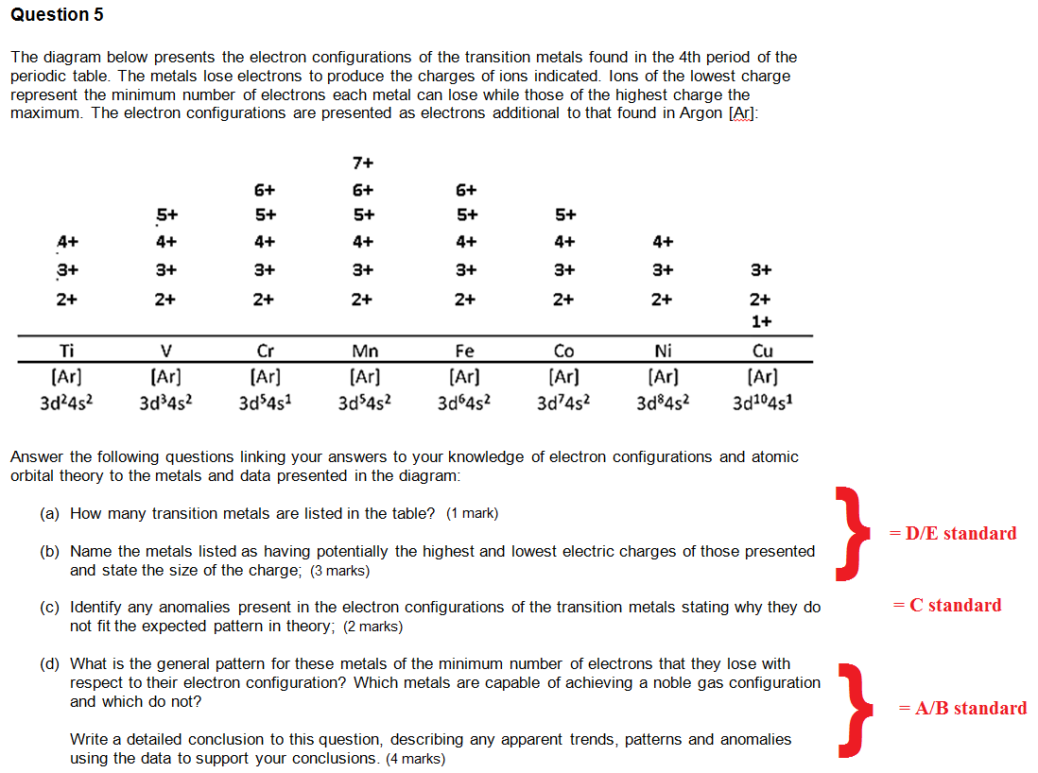

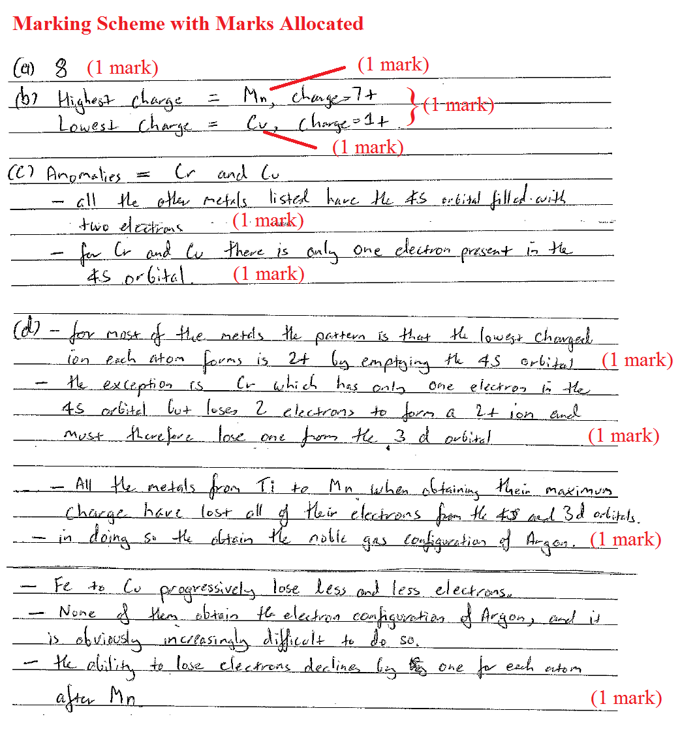

2. Extended Answer Questions without Explicit Multiple Components

This is another common style of Supervised Assessment question which does not contain explicitly identified component for students to complete but analysis of the stimulus and synthesis of a procedure to complete the task. Allocation of marks can often be achieved by identifying elements of the expected response. Initial marks should be allocated to the elements involving lower cognitive demand reflecting the ‘D’/‘E’ criteria, followed by the allocation of marks to the elements reflecting fundamental knowledge/investigative, evaluating skills in ‘C’ criteria and finally the allocation of marks to the higher order skills in the ‘A’/‘B’ criteria requiring assembling, integration and synthesis of information.

Marks should be allocated in a similar fashion as in explicit multiple component questions with no more than 40% of the total marks aligned to the ‘A’/‘B’ criteria. An example is shown in Figure 4:

Figure 4. Exemplar of the Use of Marks in a Non-Multiple Component SA Question

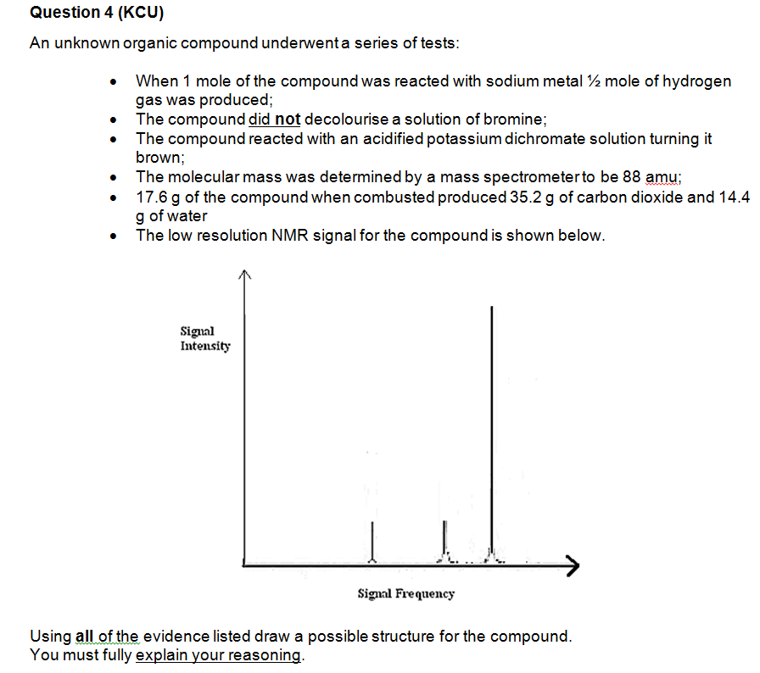

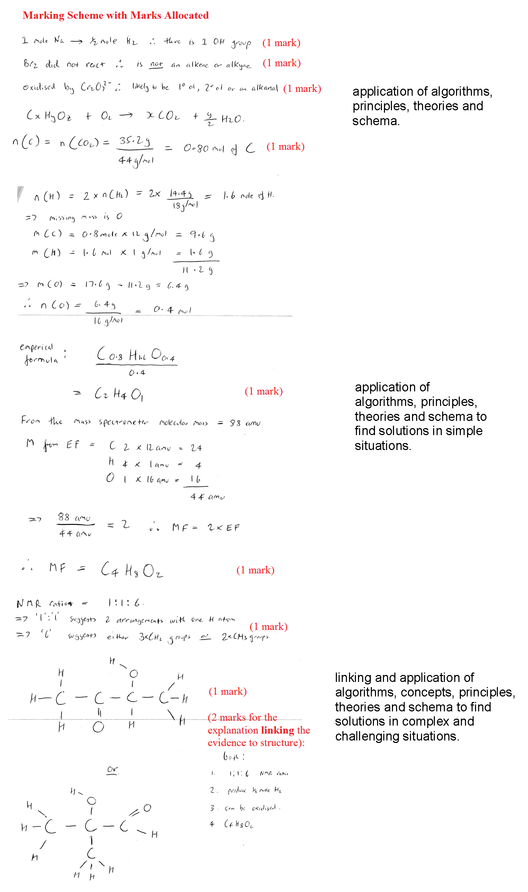

3. Holistic Marking (Extended Response SA Tasks, EEIs and ERTs)

While many schools use traditional exam formats for Supervised Assessments in some instances other formats are used such as analytical essays responding to a stimulus. In these tasks allocation of marks to specific elements of student responses while still accurately reflecting the criteria may be more problematic as evidence for the attainment of a standard may be spread throughout the response and students may respond to the stimulus in unanticipated ways. Extended Experimental Investigations (EEIs) and Extended Response Tasks (ERTs) pose similar problems to those in Extended Response SA tasks.

In some other states marks are allocated to specific sections of EEI reports and ERTs, the marks gained from each section being aggregated to create a final overall mark. This is possible as lengthy, single criteria describe the five A to E standards in those states. In the Queensland syllabuses the criteria are spread over three general objectives (e.g., KCU, IP and EC) each of which is further divided into three sub-objectives (e.g., recall and interpret, describe and explain, link and apply in KCU). As evidence for each of the sub-objectives may be found in different sections of a student’s work allocating marks to specific sections and aligning them with the criteria can be difficult.

Queensland science teachers utilise a holistic approach when marking assessment that involves lengthy student responses having to use professional judgement to grade tasks standards in the five bands, A to E, divided into one third sub-bands to give a 15 point scale. The restriction of teachers to this 15 point scale was raised in many submissions as a point of contention to the parliamentary inquiry. Teachers suggested that they were capable of finer grained judgements and highlighted this limitation as introducing an unacceptably large source of error when determining LOAs and rung placements.

The restriction to the 15 point scale in Queensland can be traced back to the study of Masters and McBride in 1994 (*An Investigation of the Comparability of Teachers’ Assessment of Student Folios*). They reported high inter-marker reliability when reviewing student folios using a 50 point scale to within +/- 2 rungs. This reflected an expected range of 4 rungs for professional judgement in most cases – hence the adoption of an accuracy of one third of a band accuracy in the Queensland syllabuses. The same study reported that a significant proportion of Mathematics and Chemistry teachers differed in their judgement by as little as +/- 1 rung. Masters and McBride also highlighted the issue that a reduced number of levels into which student work can be placed increases the impact of negative outcomes on student results where errors in placement occur.

In other states extended response assessment in a range of subject disciplines are routinely marked out of 25 or 50. A good case can be made to do so here, as either number can be easily converted into a percentage and shows a greater level of discrimination than the current 15 point scale. In Victoria when teachers mark work holistically the rationale used is to first decide if a student’s task is of an A to E standard, decide if it is in the high, middle or low range, decide if it is high middle or low within that range and then allocate a score.

The simplest means to allocate marks in one of these tasks is to introduce them into the criteria sheet as shown in Figure 5. The choice of using a maximum of 25 or 50 marks can be left to discretion of the school but the same maximum mark needs to be applied to each component in the matrix. The marks for the components of each of the three general objectives can then be aggregated. In order to reflect the syllabus requirement of equivalence of the global objects a percentage must be calculated for each of the objectives which from the percentage cut-offs can be used to identify the standard.

Figure 5. Exemplar of the Use of Marks in a Criteria Sheet for an EEI

