

Mrs Menkens

Chair, Queensland Parliament Education and Innovation Committee

Inquiry into Assessment Methods in Senior Maths, Chemistry and Physics

100 George Street

BRISBANE Q 4069

15 July 2013

Dear Mrs. Menkens,

We thank the committee for the opportunity extended to Professor Ridd to make some introductory comments at the outset of this Inquiry. We would hope that you will also accept this letter for the public record at the conclusion of proceedings and submissions. In particular, we wish firstly to respond to various claims of the Queensland Studies Authority (QSA) and secondly to make some concluding remarks, and hope our observations will be of some use to the committee.

**A response to QSA claims**

A number of false and misleading claims have been made by the QSA during the course of this inquiry, some of which have gone unanswered. Our response to those claims is set out in Appendix A.

**Concluding remarks**

It is now evident that the QSA methods of assessment are radical and almost unique in the world. This would not necessarily be a problem if there were evidence that the system performs at least as well as good education systems in other jurisdictions. The onus of proof however is upon the QSA to demonstrate this, but the QSA failed the Inquiry in this regard.

Instead considerable evidence was presented by parents, teachers and university discipline academics that indicated that the QSA’s assessment systems are -

* unreliable, over-complicated, and difficult or impossible to understand,
* open to cheating,
* excessively inefficient and time consuming for both students and teachers,
* discriminatory against boys,
* disadvantageous to rural/remote schools, schools in lower socio-economic areas and schools with a high proportion of students from non-English speaking backgrounds.

The QSA hasredefined and impoverished Maths, Physics and Chemistry by over-assessing capabilities which are marginally related to these subjects, e.g. the overuse of writing tasks. These methods are no doubt in large part responsible for the widely acknowledged decline in maths/science standards of Year 12 students entering Queensland universities, as attested to in numerous testimonies from university discipline academics – see Appendix B.

On the positive side the introduction of Experimental Investigations in Chemistry and Physics is appreciated by many, however the implementation has been botched by the excessive length, and overemphasis of these tasks in the overall assessment and on teaching time.

The QSA attitude has been to keep its head in the sand and dispute that there is anything amiss. The closest that the QSA and its supporters have come to accepting that real problems exist is to claim that a little more professional development to train the teachers would have been useful. This is not correct as no amount of training can make this system work. It also implies that after 6 years of implementation, teachers are not clever enough to understand what they are supposed to do.

The QSA has also seriously misled the inquiry by claiming that its systems are nothing like the Western Australian system which was recently scrapped after the education minister was forced to resign.

There is clearly considerable fear amongst teachers and parents judging by the most remarkable statistic from the inquiry, *viz.* 100% of the 73 submissions with names suppressed were from authors who opposed the QSA.

In addition our submissions analysis detailed in Appendix C shows that the only group where the QSA found any significant support was from the education hierarchy - teacher’s organisations, teachers in positions of authority, and education academics at universities. This loose group of like-minded and self-selecting educationalists have controlled Queensland education for too long without, until now, being subject to any scrutiny. They are out of touch with the expectations of the general community.

Because the issue of assessment is merely a symptom of a much broader malaise within the Queensland education hierarchy, the committee may have a difficult task deciding what to do. A first step however to restoring Queensland schools to international standards must be to **abolish the QSA and form a new organisation** which is properly responsible to parliament and the education minister. In any case, with the introduction of the national curriculum, at least half of the function of the QSA has been removed and thus major restructuring is inevitable.

To conclude, we commend the Inquiry on its remarkable success in opening up the debate on this issue and for finally allowing the voices to be heard of teachers, parents and academics who have serious and valid concerns about our education system. For that we are deeply grateful.

We wish you the best in your deliberations.

Yours faithfully

 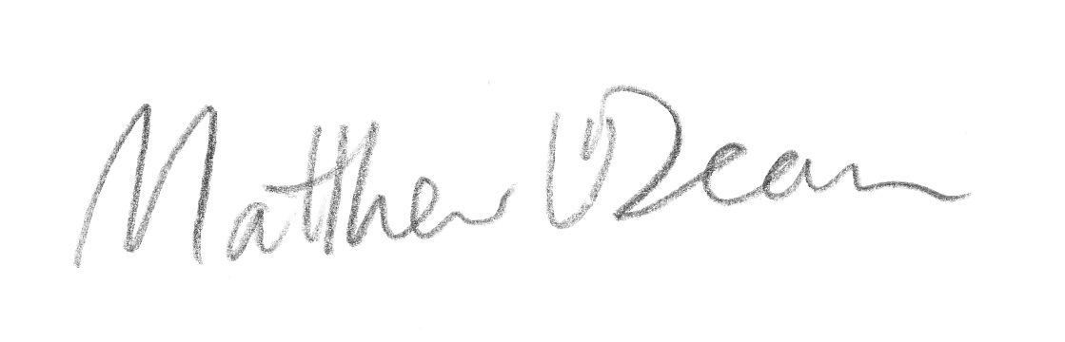

Prof  Peter Ridd with the assistance of Dr Matthew Dean

HOD Physics,

School of Engineering and Physical Sciences, JCU

**Appendix A.**

**A Selection of False and Misleading Claims made by QSA to Parliament, 7 March 2013**

**False Claim 1**

*"The assessment system we have in place in Queensland today has evolved over 40 years. It is not new and bears no relationship to the system of outcomes based education recently discarded in Western Australia."*

*- Mrs Walton, 7 March, page 2*

"The QSA is employing a trick of semantics to distance its system from the hated OBE system. One only has to look at the assessment matrix to realise it is very much influenced by outcomes based education. Both systems synthetically divide Mathematics into different components of learning. The QSA has three “criteria” (the word “outcome” can be used with the same meaning) which are assessed separately. They are “Knowledge and procedures”, “Modeling and problem solving”, and “Communication and justification”. OBE also divides assessment into the “outcomes” (or “criteria”) such as “Clarifying, choosing, using, checking and interpreting, and communicating”. Each is assessed separately, without numerical marks as is done in Queensland. Needless to say, both outcomes based education and Queensland’s assessments are the products of sociologists and psychologists, not mathematicians or empirical scientists. To divide human reasoning and assess components separately does not make sense. It goes against the epistemology of human thought processes."

- submission 19

**Misleading Claim 2**

*"The foundation of the current system that all assessment is school based has been in place for over four decades and has attracted the favourable attention of academics and educationalists internationally."*

*- Mrs Walton, 7 March, page 3*

Favourable attention has only come from education theorists. No other part of the world adopts this system. See submission 228. Imitation is the sincerest form of flattery but other jurisdictions have not followed Queensland’s lead.

**False Claim 3**

*"Achievement standards are fixed reference points used by all schools to describe how well students have achieved the objectives in the syllabus."*

*- Mrs Walton, 7 March, page 3*

QSA's tables of paragraphs are subjective, not fixed. It is clear that the majority of the submissions reported considerable difficulty with these supposedly fixed standards.

- most submissions to this inquiry

**False Claim 4**

*"Secondly, the system builds the professionalism of our teachers by encouraging their ownership in the assessment process and making them accountable for their judgements."*

*- Mrs Walton, 7 March, page 4*

Teachers are demoralised and overworked under QSA by having to each 're-invent the wheel' every year. Teachers express their professional judgement by rejecting QSA's unreliable and invalid methods.

**False Claim 5**

*"Thirdly, government benefits from a system that is fair, reliable and highly cost-effective."*

*- Mrs Walton, 7 March, page 4*

Social moderation has been demonstrated to be unfair and unreliable to this inquiry: Teachers can 'cheat' on tests to make their school look good, and written assignments are often not the student's own work. This unfairness, and unreliability is exacerbated by the imposition of vague and subjective assessment methods.

No cost-benefit analysis has been presented to the inquiry. But it is difficult to see how making every school set its own tests, which are different to every other school in the state, can be an efficient use of teacher time

- most submissions

**False Claim 6**

*"Teachers show their support for the system through their very representation on review panels."*

*- Mrs Walton, 7 March, page 4*

Teachers join the panel for varying reasons including to try to understand and work the system better. This should not be interpreted as support. They have to work in the system no matter what it is or whether they support it.

85% of teachers submissions reject QSA and 96% of submissions from teachers on full teaching loads reject QSA.

**False Claim 7**

*"Queensland syllabuses are not based on the latest fads in education."*

*- Mrs Walton, 7 March, page 4*

Submission 19, 28 and the tabled document *Why Education Experts Resist Effective Practices* by D. Carnine explain how constructivism promoted by education academics is a flawed ideology. Queensland syllabi are based on constructivism which is one of the latest fads in education.

**False Claim 8**

*"Let me be clear: QSA has not banned the use of marks. QSA has not banned the use of marks."*

*- Mrs Walton, 7 March, page 5*

The majority of submissions demonstrated to this inquiry that QSA has effectively banned marks.

**False Claim 9**

*"... skills our children will learn in the classroom will be obsolete by the time they enter the workforce."*

*- Mrs Walton, 7 March, page 6*

False. Mathematics, Physics and Chemistry describe the unchanging language of the physical world. These laws of nature will still apply when children enter the workforce and beyond. Educational theories will probably change, however, to whatever is the passing fad at that time.

**False Claim 10**

*"But despite the best efforts, there still appear to be instances where students exceed the word length. It is not the role of panels to enforce word lengths. They are primarily concerned with the way in which a student's work meets the standards in the syllabus. Schools consciously make this decision, not the Queensland Studies Authority."*

*- Mrs Walton, 7 March, page 6*

QSA is responsible for designing assessment criteria which cannot all be confidently satisfied within short essays. Students write long assignments to try to fulfil these criteria. QSA's own website exemplars are 4000 and 6000 words long. Clearly QSA is responsible as QSA is responsible for ALL assessment in Queensland.

**False Claim 11**

*"There is not a decline."*

*- Mrs Walton, 7 March, page 6*

See for example, submissions 28 and 253, and QSA's own tabled data for outlines of our forty-year decline in mathematics and mathematical sciences.

***Misleading Claim 12***

*"... academics, including the head of the mathematics department at the University of Queensland, Professor Joe Grotowski, consider the content of Queensland's mathematics B and mathematics C syllabuses to be good preparation for university."*

*- Mrs Walton, 7 March, page 7*

"In summary, from our submission, we have students entering tertiary study with weak mathematical skills despite the fact that they are getting an SA or better in maths B. This is not down to the subject, the mathematical content of the syllabus; it is down to the assessment."

- Prof Grotowski, 22 May, page 28

**False Claim 13**

*"Marks based systems tended to emphasise lower order thinking, while examinations based on criteria in syllabuses tended to award greater credit for higher order thinking questions."*

*- Mrs Walton, 7 March, page 7*

“Higher order thinking” has a specific meaning to education theorists, different from what scientists and the general public might expect. To education theorists, it refers to *creating, evaluating*and*analyzing*, which they regard as 'higher' or more important than *applying,* *understanding* and *remembering*. This approach does not produce good mathematics (or physics) students. For example, a difficult maths/physics problem could be considered 'lower order', while an easy problem with some related creative writing attached, will be considered 'higher order'. The words "higher order thinking" sound good, but are clearly the wrong approach to the mathematical sciences. See also submissions 28 and 30.

In any case, a marks based system can easily be used to fairly assess any type of student skill or knowledge as is done in virtually every other education system in the world.

**False Claim 14**

*"We used marks exclusively during the seventies... One of the problems with the system was that when teachers gathered in moderation meetings...they would compare their percentages or compare their marks. What was missing was a standard."*

*- Mr Jordan, 7 March, page 8*

What was missing was a common, state-wide, exam to assist in comparing results. Tables of paragraphs (which QSA call 'standards') do not help with this task.

**False Claim 15**

*"The authority has learning area reference groups which are around courses of work—for example the mathematics learning area reference group—and on those groups are academics. On the mathematics learning area reference group we have Dr Joe Grotowski, the head of the mathematics faculty at the University of Queensland. I had asked this deliberate question of that particular academic around the maths B and maths C syllabus in light of comments that have been made: are these appropriate syllabuses for students in their preparation for university? As I said in my presentation, he clearly said they are appropriate for tertiary study."*

*- Mrs Walton, 7 March, page 10*

Prof Grotowski only endorsed the mathematical topics listed in the syllabus. He did not endorse the assessment methods, or the other educational sections contained within the syllabus. See also False Claim 17 and Prof Grotowski's comments, 22 May, pages 28 and 30.

**Appendix B**

**Evidence of low standards of Queensland school graduates from discipline experts.**

“Both of us have long experience in teaching tertiary mathematics, not just to mathematicians but to economists, to scientists in general, to business students and to all sorts of students in service courses and specialised courses as well.

What we see is a large and increasingly larger cohort of students coming in with a sound achievement in maths B who do not have sufficient mastery of these mathematical techniques and content... We are talking about students who are going to become engineers who are going to be building our bridges; we are talking about biology students as well. They simply do not have the mathematic content and skills at a sufficient level, so there is a disconnect happening here. ...

In summary, from our submission, we have students entering tertiary study with weak mathematical skills despite the fact that they are getting an SA or better in maths B. Numerical marking schemes can and do pick out the criteria for assessment very well, and we believe that they should be supported and encouraged.”

**Prof Joe Grotowski, Head of Mathematics, UQ** (Transcript 22 May)

"... there are many students entering tertiary study, with at least a Sound Achievement in Mathematics B and/or C, whose skills and knowledge is very weak, and not consistent with any particular mastery of the mathematical content and knowledge identified in the syllabi. We expressed this view very clearly in both meetings with the QSA. It is also our expert view that the number and proportion of such students has increased dramatically in recent years.

Indeed, in a substantial number of cases, students appear to be incapable of demonstrating proficiency at some mathematical techniques that are covered prior to Year 11. This observation is shared by colleagues in mathematics departments at other universities in Queensland, and is particularly alarming.

This suggests that there is a significant mismatch between what is being identified as a Sound Achievement in mathematics by the secondary education system, and what we would understand as a sufficient understanding and mastery of the mathematics that is being taught."

**Prof Joe Grotowski, Head of Mathematics** and **Prof Peter Adams**,

**Associate Dean (Academic), Faculty of Science** (submission 220)

"Furthermore, with regard to algebra skills, it was found that fewer than 50% could successfully solve a simple equation."

**Prof Ian Turner, Head, Mathematical Sciences School, QUT** (submission 266)

"Unfortunately, most students arriving at The University of Queensland to study degrees in science or engineering, do not have fundamental (high school) mathematics skills required for these degrees. Many of these students even do not know the times-tables, or how to add fractions."

**Dr Matthew Dean** (submission 28)

"What I have seen of first-year students as I have been lecturing is that they have been exposed to the relevant mathematics topics but they cannot do them, and that is demoralising for students."

**Dr Matthew Dean**, Transcript 22 May

We have been advised by Dr Shaun Belward (HOD Mathematics, JCU) that his submission demonstrated that students with sound achievement in year 12 Maths B were unable to cope with year 10 standard questions.

Reported by **Prof Peter Ridd, HOD Physics, James Cook University** (submission 98)

"...the standards of students on entry to university are feeble, especially in Arithmetic and Algebra at the Year 10 level, i.e. students entering first year university with a sound achievement in year 12 maths B struggle with year 10 level mathematics."

**Prof Peter Ridd, HOD Physics, James Cook University** (submission 98)

"Claims such as "world's best practice" in an educational setting are at best indefensible and at worst a snowjob intended to stifle discussion...

The way to proceed is to listen to the experienced teachers. Their accumulated knowledge is gold.”

**Dr Ashley Plank** (submission 275)

"I teach your sons and daughters undergraduate science and train them as PhDs. For the past 20 years I have been flabbergasted by their sub-standard skills in maths and English. I encounter many, many university students who can’t work out percentages, and almost none of them have adequate skills in spelling or grammar. Interestingly, I encounter these problems less these days – thanks to the higher numbers of foreign students! I did not understand the general lack of core skills in our university students – until my own son started his education in Queensland schools."

**Prof Jenny Stow, Deputy Director (Research), IMB,** UQ (submission 50)

"The main motivation for my submission is that the skills of many Queensland mathematics B graduates are insufficient to study the subject at a first year University level. This in turn jeopardises the ability of our University graduates in science, mathematics and engineering to reach an international standard, and support Australia’s aspirations to maintain its ability for scientific and technological innovation.

The subject content as outlined in the Mathematics B curriculum appears to be reasonable, but the standards at which it is learned and assessed does not. The criterion referenced assessment and written assignments contained in the current syllabus appear to significantly distract excellent high school teachers from focusing on more important mathematical topics and content."

**Assoc Prof Anthony Roberts. Mathematics, UQ** (submission 106)

"For 20 years I was heavily involved in teaching the introductory mathematics course for students intending to study physics, mathematics, chemistry or engineering at Griffith.... The pre-requisite for entry into these courses was a Sound Achievement in Maths B. Over this time there was a noticeable drop in the ability of average students to quickly and confidently handle basic mental arithmetic (addition, division by 10), to handle fractions and to use basic algebra (as learnt in grades 10 and 11)."

**Dr Tony O'Conner, Mathematics, Griffith University**, retired (submission 206)

“ national testing shows that Queensland is one of the lower performing States... Unfortunately many experienced teacher have or are about to retire and at least in Mathematics and science there are insufficient top quality teachers to replace them.”

**Dr Stephen Norton, Senior Lecturer, Mathematics Education, Griffith University** (submission 30)

**Appendix C Analysis of Submissions**

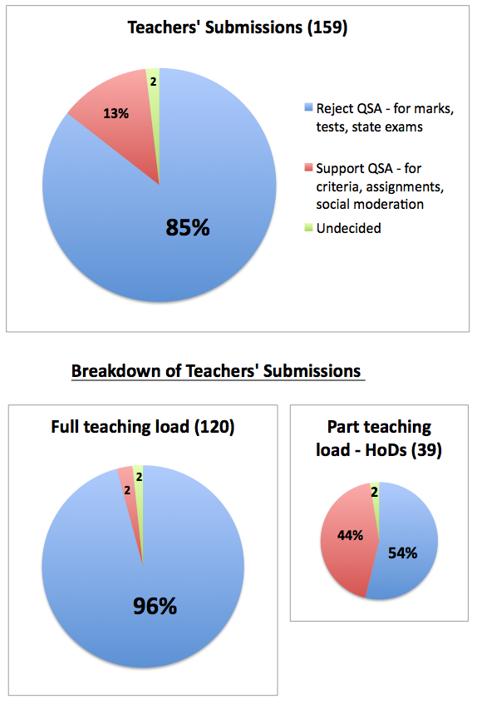 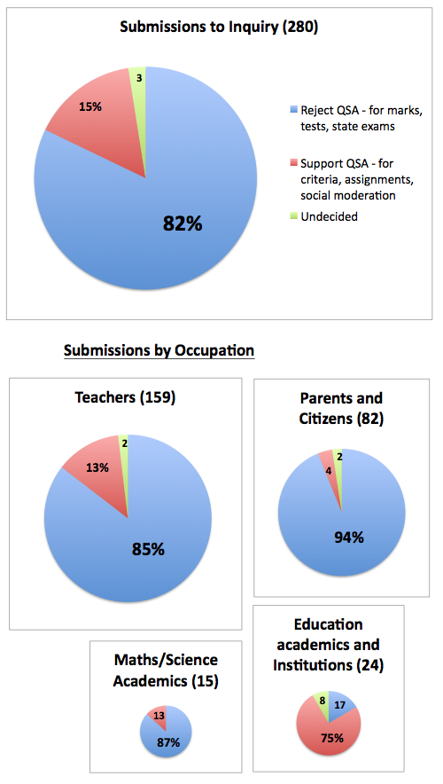

**Summary of Submissions to the**

**Queensland Parliamentary Inquiry into Assessment Methods for Senior Maths, Physics and Chemistry**

|  |  |  |  |  |  |  |  |  |  |  |  |  |  |  |
| --- | --- | --- | --- | --- | --- | --- | --- | --- | --- | --- | --- | --- | --- | --- |
|  | **Parents, students, other profession-als & 'not stated'** | | **Teachers on a full teaching load** | | **Teachers**  **on a partial teaching load**  **(HODS)** | | **Maths or Science**  **Discipline academics** | | **Education academics** | | **Education agencies (including QSA itself)** | | **Sub-totals for each group** | |
|  | # | % | # | % | # | % | # | % | # | % | # | % | **#** | % |
| **FOR CHANGE\*** | 77 | **94** | 115 | **96** | 21 | 54 | 13 | 87 | 2 | 13 | 2 | 13 | 230 | **82** |
| AGAINST CHANGE** | 3 | 4 | 3 | 2 | 17 | 44 | 2 | 13 | 6 | 75 | 12 | 75 | 43 | 16 |
| NEUTRAL | 2 | 2 | 2 | 2 | 1 | 2 | 0 | 0 | 0 | 13 | 2 | 13 | 7 | 2 |
| TOTAL | 82 | 100 | 120 | 100 | 39 | 100 | 15 | 100 | 8 | 100 | 16 | 100 | 280 | **100%** |

* Those in favour of change/overhaul in Qld, i.e. marks, tests and state exam

* Those who support the old ways currently under inquiry, i.e. criteria, assignments and social moderation

Total submissions = 288=5 repeats+3 confidential+280 readable, personal submissions

**Classification of Submissions**

|  |  |  |
| --- | --- | --- |
| **Submission Type** | **Number of**  **Submissions** | **Which Submissions** |
| **For change, i.e.**  **marks, tests, and/or**  **state exams** | **230** | **1, 2, 3, 4, 5, 8, 9, 14,15, 17, 18, 18a, 19, 20, 21, 22, 23, 25, 27, 28,**  **29, 30, 31, 34, 35, 36, 37, 38, 39, 40, 41, 42, 44, 45, 47, 49, 50,**  **51, 52, 53, 55, 56, 58, 59, 60, 61, 62, 63, 64, 65, 66, 67, 68, 69,**  **70, 71, 72, 73, 74, 75, 77, 78, 79, 80, 81, 82, 83, 84, 86, 87, 88,**  **89, 90, 91, 93, 94, 95, 96, 97, 98, 99, 100, 101, 102, 103, 104,**  **105, 106, 107, 109, 110, 113, 114, 115, 116, 117, 118, 119, 121,**  **123, 124, 126, 127, 128, 130, 131, 132, 133, 134, 137, 138, 139,**  **140, 141, 142, 143, 145, 147, 148, 150, 152, 153, 154, 155, 156,**  **159, 160, 162, 163, 164, 165, 166, 167, 168, 169, 170, 171, 172,**  **173, 174, 175, 178, 179, 180, 181, 183, 184, 185, 186, 187, 188,**  **189, 190, 191, 194, 195, 196, 199, 200, 201, 202, 203, 204, 205,**  **206, 207, 208, 209, 210, 211, 213, 214, 215, 217, 218, 219, 220,**  **222, 223, 225, 227, 228, 230, 231, 232, 233, 235, 236, 237, 238,**  **239, 240, 241, 242, 245, 247, 249, 251, 252, 253, 254, 255, 257,**  **258, 259, 260, 261, 262, 263, 264, 265, 267, 268, 269, 270, 271,**  **272, 274, 275, 276, 277, 278, 279, 280, 281, 283, 284, 285, 286,**  **287, 288** |
| **For the old ways,**  **criteria, assignments,**  **and**  **social moderation** | **43** | **6, 7, 11, 12, 13, 33, 46, 48, 54, 57, 76, 85, 92, 108, 122, 129, 136,**  **146, 149, 151, 157, 158, 161, 176, 177, 192, 193, 197, 198, 212,**  **216, 221, 224, 226, 229, 234, 243, 244, 246, 248, 250, 256, 273** |
| **Undecided** | **7** | **10, 24, 26, 32, 43, 144, 266** |
| **Confidential** | **3** | **125, 135, 282** |
| **Repeats, withdrawn** | **5** |  |
| **Total** | **288** |  |