CRITERIA-STANDARDS SHEETS rejected by many math, science teachers & students in Yrs 11 & 12.

Notice the standards A-E across the top of the row – which cannot be added up.

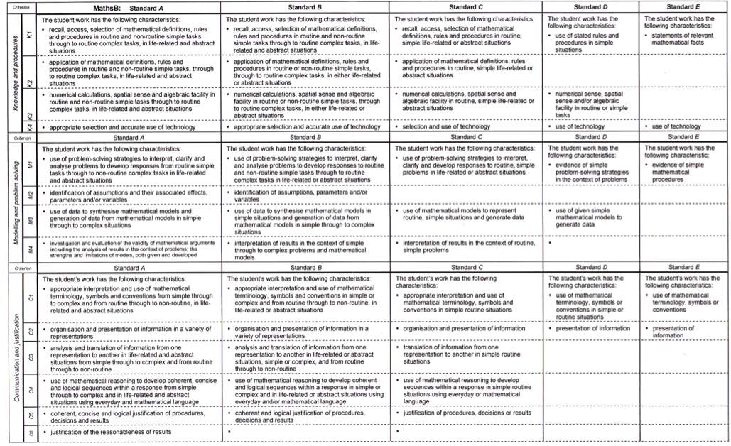

LASDs SHEETS now, a similar check-box rubric (grid) for Years Prep – 10 (see below), are introduced.

Although strongly rejected by many Senior teachers and students, an apparent adaptation of the above ‘criteria-standards’ based sheets are being used by Queensland Prep-10 teachers was rolled-out in 2012 and 2013 … they are called drafts but being used already. These grids or matrix sheets are described as having 5-point **standard**s across the top again. These grids have no marks but rather holistic ‘on-balance’ combinations of letters under a 5-band scale. They are not required by law. They are an unnecessary, complicated add-on template superimposed on **achievement standards already provided** by the **new Australian Curriculum**.

These sheets, also force teachers to pre-judge each and every student’s results into pre-ordained tick-boxes which – for many maths and science subjects - still do not say what the child actually got right and wrong. For many students without the ‘behaviour’ defined in the high-end scale (eg, “explanation”, “connection” of the answers) even if they have many fully correct answers, this will **bias** the child’s results into the lower end of the scale across the ‘standards’ cut-offs (towards the right side in the primary state school marking grids) This could lead to a combined holistic total of lower-scale letters which will be converted to the lower ‘D’ end of the scale for parents’ report cards.

Year 1 Math stds- QSA style 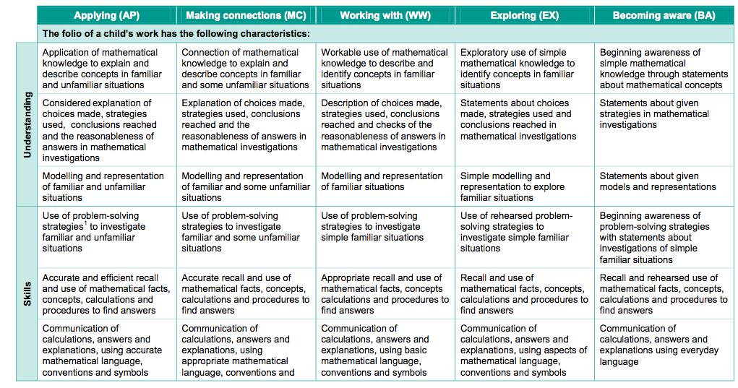

To confuse things, they have been issued with a 2-year level guide, which could confuse parents even more.